WHERE ,AND,OR & CRUD

LOAD THE DOCUMENT

#DOWNLOAD THE student csv from this link

#IMPORT THE DATA TO THE COLLECTION CTREATED DATA

WHERE:

In MongoDB, the "where" operator is not used like in traditional SQL databases. Instead, MongoDB uses the "find" method to query documents in a collection based on specific criteria. You can specify the criteria inside the "find" method to filter the results you want. It's a bit different from SQL, but once you get the hang of it, it's pretty cool! Let me know if you need more info on querying in MongoDB



AND

In MongoDB, you can use the "and" operator by specifying multiple conditions within the same query. To do this, you can use the "$and" operator, which allows you to combine multiple expressions. Each expression inside the "$and" operator must evaluate to true for the document to be included in the result set.



OR

In MongoDB, you can use the "or" operator to query documents based on multiple conditions where at least one of the conditions needs to be true for the document to be included in the result set. To use the "or" operator, you can use the "$or" operator in your query.



CRUD

● C - Create / Insert

● R - Remove

● U - update

● D - Delete

This is applicable for a Collection (Table) or a Document (Row)

INSERT

In MongoDB, to insert data into a collection, you can use the "insertOne" or "insertMany" methods.

If you want to insert a single document, you can use the "insertOne" method like this:

db.collection.insertOne({ key: value, key2: value2, ... })

If you want to insert multiple documents at once, you can use the "insertMany" method like this:

db.collection.insertMany([

{ key: value, key2: value2, ... },

{ key: value, key2: value2, ... },

...

])

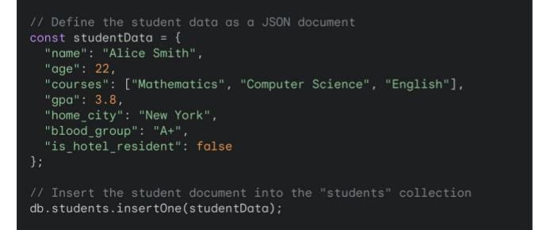

UPDATE:

n MongoDB, to update documents in a collection, you can use the "updateOne" or "updateMany" methods.

If you want to update a single document, you can use the "updateOne" method like this:

db.collection.updateOne({ filter criteria }, { $set: { key: value, key2: value2, ... } })

If you want to update multiple documents that match a filter, you can use the "updateMany" method like this:

db.collection.updateMany({ filter criteria }, { $set: { key: value, key2: value2, ... } })

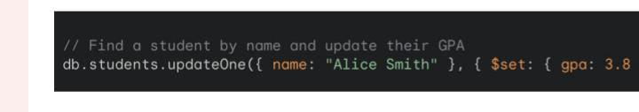

DELETE

To delete documents in MongoDB, you can use the "deleteOne" or "deleteMany" methods.

If you want to delete a single document, you can use the "deleteOne" method like this:

db.collection.deleteOne({ filter criteria })

If you want to delete multiple documents that match a filter, you can use the "deleteMany" method like this:

db.collection.deleteMany({ filter criteria })

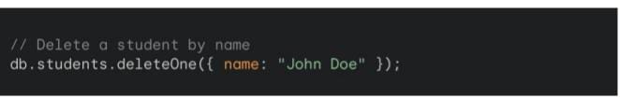

UPDATE MANY

To update multiple documents in MongoDB, you can use the "updateMany" method. This method allows you to update all documents in a collection that match a specified filter.

Here's an example of how you can use the "updateMany" method in MongoDB:

db.collection.updateMany(

{ filter criteria },

{ $set: { key: value, key2: value2, ... } }

)

PROJECTION

The project operator in MongoDB is used to specify or restrict the fields that should be returned in the query results. It allows you to control which fields are included or excluded in the output documents.

